Institutional Review Board (IRB) - Full Review Form
Please complete the following sections in enough detail for the IRB to understand the nature, intent, and procedure of your project. Enter the following information within this document.

1. Title: Complex Musical Preference and Introverted Personality Experiment

2. Project Summary:
Past research has indicated that people who prefer certain types of music tend to exhibit certain characteristics. The goal of this research is to investigate the relationship between complex musical preferences and introverts.

3. Research Question:

Are participants who prefer complex music such as jazz, classical, melodic, soundscapes, etc. introverts?
Participants who prefer to listen to complex music such as jazz, classical, melodic, soundscapes, etc., are likely to be introverts by nature.

4. Foreseeable Benefits:
a. Understanding that musical preference does affect our personality traits?

b. Society members who are eighteen and older who are shy, isolated, and introverted that prefer to listen to complex music can gain understanding about their particular personality traits. Knowledge regarding personality traits could help those who are isolated, shy, or introverted.

c. The outcome of this research can assist the medical, and psychological professional with vital information about the impact that complex musical preference has on the personality trait of an introverted person.

5. Target Sample Demographics:
a. Twenty participants male and female participants age: 18 and older

b. Inclusion Criteria: Participants must be eighteen or older, musical preference must be one, or all of the following (classical, jazz, soundscape, melodic), participant must be an introvert (according to the operational definition).
Exclusion Criteria: Participants can not be younger than eighteen years old, participants who are extroverts, participants who do not listen to complex music, i.e.,; ( jazz, classical, soundscapes, melodic, etc.).

c. The participant will be assessed using an inclusive/exclusive assessment review form.

d. Estancia Henderson – Researcher and Investigator

6. Procedures to identify and mitigate risk to human subjects:
a. Researcher Estancia Henderson will choose twenty participants. The participants will be female or male. The participants will be eighteen years old or older than eighteen years old.

(1) The researcher Estancia Henderson will be invited to participate in person, or via phone call, participants will be invited to show the researcher Estancia Henderson proper identification, verifying that they are eighteen years old or older.

(2) The researcher Estancia Henderson will make the initial contact. The contact will be done by the researcher Estancia Henderson’s private home office, in Victorville, California.

(3) The invitation is attached to this document

(4) The participants will be pooled from family, colleagues, business partners, friends, and associates.

b. Consenting Process to protect privacy
Privacy is defined as having control over extent, timing, and circumstance of sharing oneself with others. Threats to privacy are mitigated by the participant’s informed consent for participation in the research.

(1) 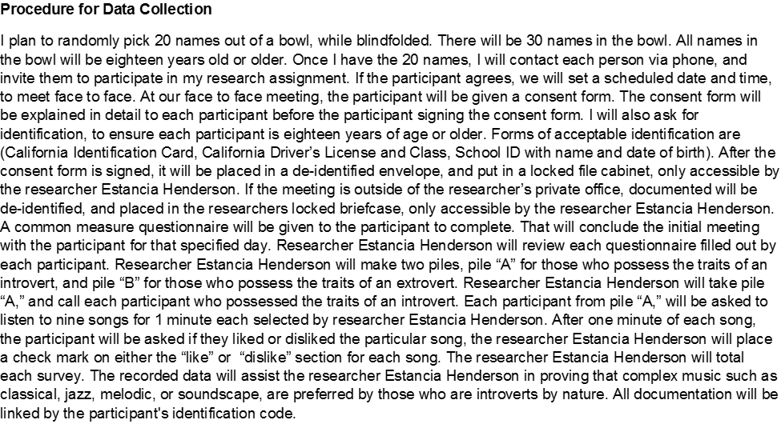
(2) Copy of Informed Consent Form is attached
(3) Who will discuss Informed Consent documents with potential participants or their guardians?
Name: Estancia Henderson
Title: Researcher/ Student of Azusa Pacific University College
Estancia Henderson/ Researcher speaks English and will communicate to all participants in the English Language.

No training is required as the researcher Estancia Henderson will ensure all participants are aware of the procedures, privacy information and pertinent information of the consent form for their participation in this research study.
Are all members of the research team NIH certified? Yes

(4) What is the procedure for persons who administer Informed Consent to document that the potential participant understands the terms of the consent? See the last paragraph of the Informed Consent template.

(5) The informed consent forms will be placed in envelope “A,” and sealed, The Envelope “A” will be put in a larger envelope “B,” and sealed. The participant's name will be deidentified by using the first two letters of their last name, and the first two letters of their first name, example: Jane Doe would be “DoJa.” Afterward, the file will be locked in a file cabinet, to ensure confidentiality.
(6) No, I do not plan to use electronic survey’s

c. Steps to protect confidentiality of data
Confidentiality pertains to treatment of information that an individual discloses in a relationship of trust with the expectation that it will not be divulged to others without permission. Confidentiality is often protected by anonymous responses or by de-identifying data by replacing names with codes.
What are your procedures to protect the confidentiality of participants?
All data collection (consent form, questionnaire, research data, inventory sheets) will be deidentified, forms will be placed in envelope “A,” and sealed, The Envelope “A” will be put in a larger envelope “B,” and sealed. The participant's name will be deidentified by using the first two letters of their last name, and the first two letters of their first name, example: Jane Doe would be “DoJa.” Afterward, the file will be locked in a file cabinet, to ensure confidentiality.

d. Data retention and storage
The data will be deidentified, and locked in a file cabinet. The only person with access to the locked file cabinet is the researcher, Estancia Henderson.
e. Risks for physical discomfort and emotional distress associated with research procedures
Participant may have anxiety, possible discomfort due to music, risk of triggering a traumatic experience.
What is the anticipated evidence of physical discomfort or emotional distress?
The anticipated level of physical discomfort or emotional distress is very low.
f. How will the researcher respond to evidence of physical discomfort or emotional distress?
If a participant shows any sign of physical or mental discomfort, the research will stop immediately. The researcher Estancia Henderson will ensure that the participant is taken to the nearest emergency medical facility if needed.

What resources are available to the participant?
Emergency Medical Facilities within 1 mile.
- Kaiser Hospital
- St Mary’s Hospital

g. Host for data collection
(1) N/A
(2) No participants reside outside of the United States

7. Research Methods
For quantitative studies:
- Treatment and control conditions, including evidence of safety for participants

b. Randomization procedures

c. Data collection instruments
(1) Classical-Bach- Fugue in D Minor, Hip-Hop-Notorious B.I.G.- Juicy, Soundscape-Jtothek-Happy with you, Heavy Metal Ozzy Osborne-Crazy Train, Jazz- John Coltrane-Naima, Pop-Justin Beiber- Sorry, Blues/jazz/folk-Norah Jones-Don’t Know Why, Melodic-Goapele-Closer, Country-Randy Travis-Forever and Ever, Amen (1) common measure questionnaire (1) musical preference questionnaire (1) seven songs will play via YouTube (1) participants will listen to seven songs (1) consent form

(2) State here the evidence of instrument suitability for participants, psychometric properties, and required copyright permission
Instruments are suitable for each participant. No copyright permission needed.

- Data analysis procedures, including power analysis
After listening to one minute of each song the participant will be asked to place a check mark on the “liked” or “dislike” section for each song. The researcher will total each survey. The sample size is 20 (total participants) The mean will be decided after the researcher knows the number of participants who have introverted personality traits. Formalized data procedure will be known after the mean is established.

8. Research Plan
June,15,2017- Pull names from the bowl of 30 /Invite 20 Participants
June 16, 2017- After invitation is accepted meet to go over, and complete informed consent form.
June 17, 2017- Conduct research
June 18, 2017- Conclusion of research/ Inform Participants of outcome.

